**AWS S3 Assignments**

1. Create a new S3 bucket and upload a file to it.  
   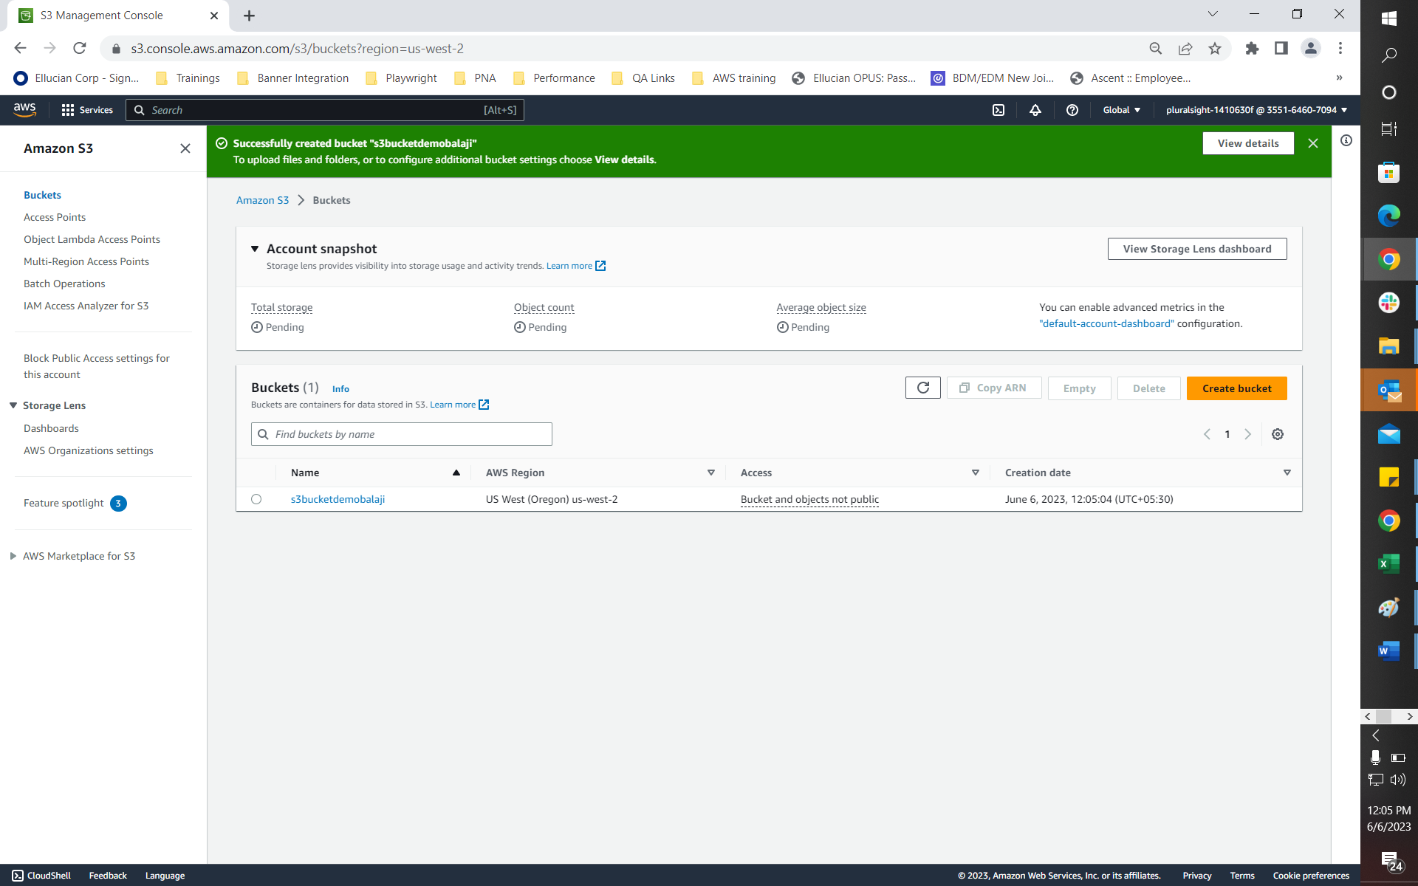  
     
   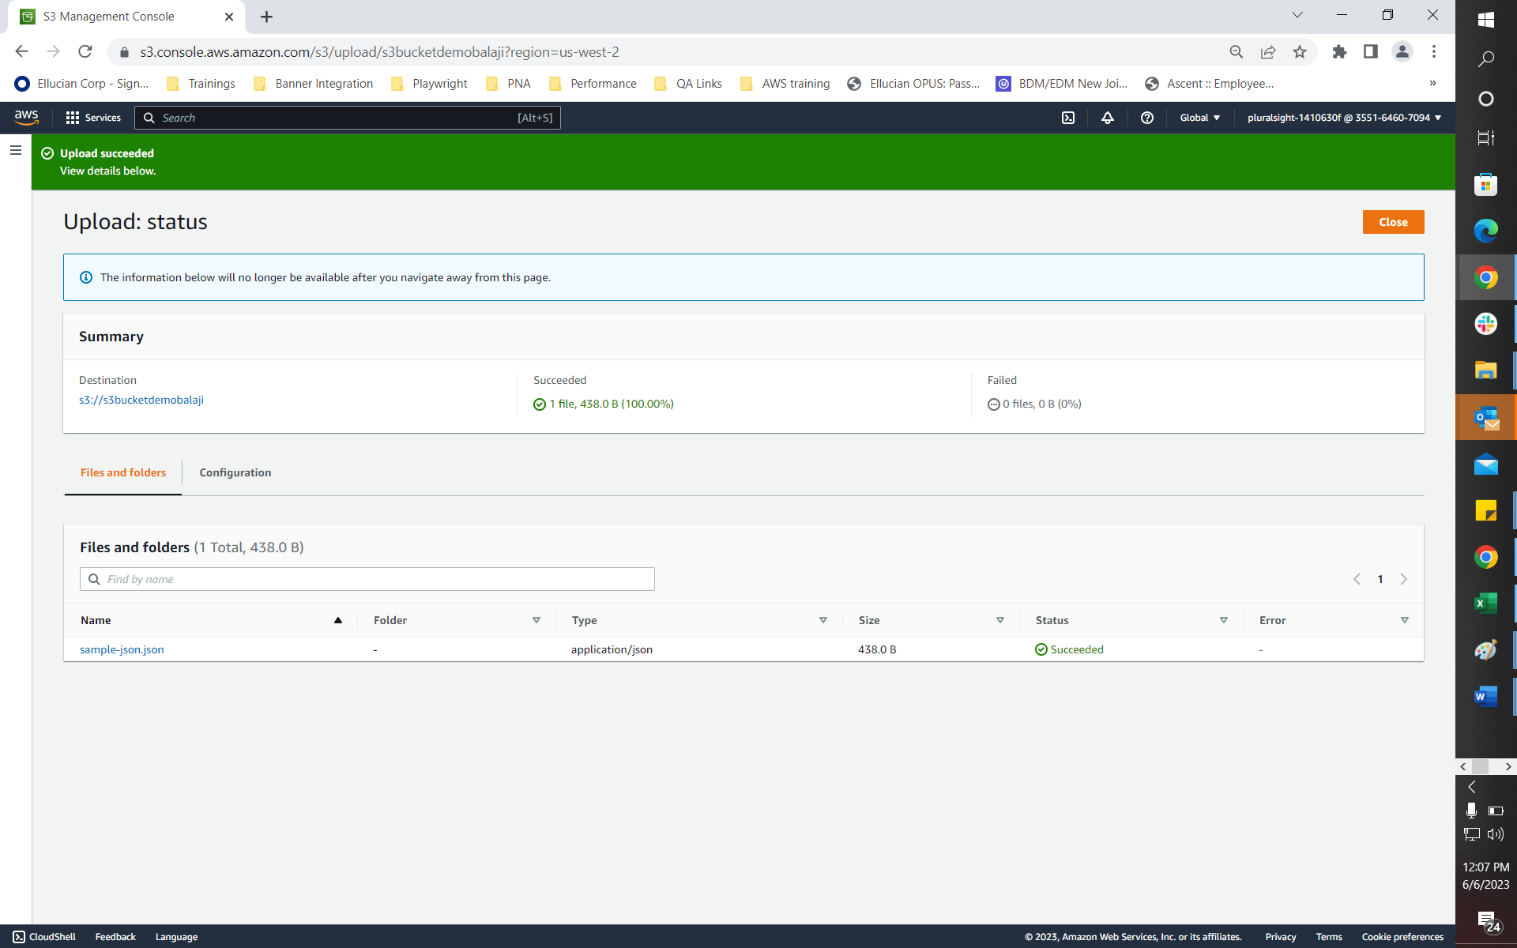
2. Enable versioning for a bucket and test versioning by creating and deleting objects.  
   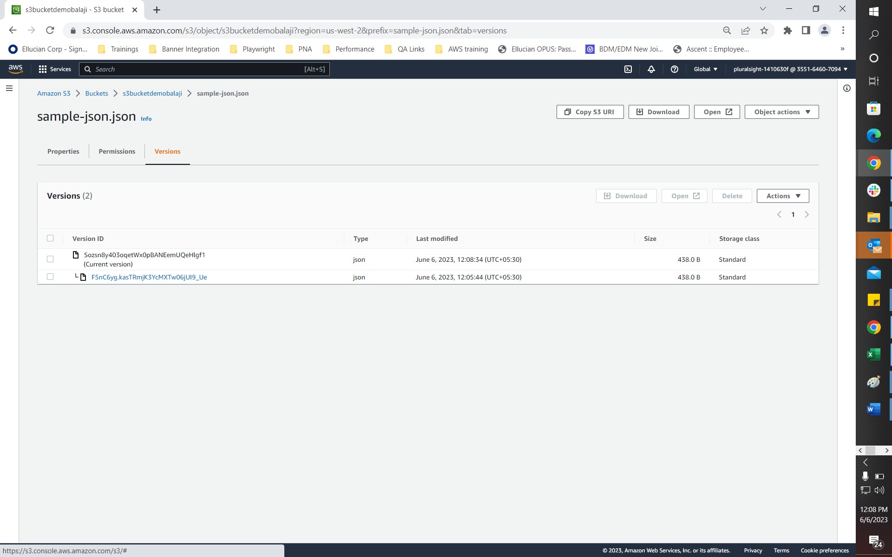  
     
   A screenshot of a computer

   Description automatically generated
3. Create a static website hosted on S3 and use S3 as the content delivery network (Use any simple static website template code available online).  
     
   A screenshot of a computer

   Description automatically generated  
     
   A screenshot of a computer

   Description automatically generated

